
UIDAI DATA HACKATHON 2026
Team Lead Name – Anushka Kushwah
Team ID =UIDAI_4718

Problem Statement & Approach

  - Problem Understanding
The Unique Identification Authority of India (UIDAI) manages Aadhaar enrollment and post-enrollment processes such as demographic updates and biometric capture. While enrollment numbers indicate outreach, true Aadhaar coverage is achieved only when demographic and biometric information is successfully completed.
The primary challenge I addressed in this analysis is to identify coverage gaps between enrollment, demographic processing, and biometric capture, and to highlight geographic, temporal, and demographic patterns that may impact Aadhaar coverage efficiency.

  - Why I chose this Analysis

I chose this analysis to answer key operational questions relevant to UIDAI, such as:
- Where do biometric and demographic update processes diverge?
- Which districts show persistent biometric coverage gaps?
- Which districts generate high operational workload without proportional new enrollments?
- Which age groups drive Aadhaar update activity?
- How does Aadhaar coverage progress over time?

By answering these questions, the dashboard aims to support data-driven decision-making, resource prioritization, and targeted interventions.

  - Analytical Approach

The analysis follows a top-down approach, starting from a national and state-level overview and gradually drilling down into district-level and demographic insights.
The approach consists of:
- High-level monitoring using key performance indicators such as total enrollment, demographic completion, biometric completion, and biometric coverage percentage.
- Temporal analysis to study trends in enrollment and biometric capture over time.
- Geographic analysis to identify districts with strong or weak biometric coverage.
- Demographic analysis to understand performance variations across age groups.
- Gap analysis to highlight differences between enrollment, demographic processing, and biometric completion.

1.4) Tool and Methodology
Power BI was selected as the primary analytical platform to perform large-scale exploratory and diagnostic analysis on UIDAI datasets. The methodology followed a structured analytics workflow—data understanding, standardization, modeling, measure design, and insight generation—ensuring analytical accuracy and interpretability.
A dimensional modeling approach was applied to integrate enrollment, demographic, and biometric datasets, enabling consistent cross-comparison across time, geography, and age groups. Interactive visual analytics were then used to identify trends, coverage gaps, and operational imbalances, translating raw data into decision-oriented insights.

1.5) Outcome of the Approach
- This structured approach ensures that:
- Senior stakeholders can quickly understand overall Aadhaar coverage performance.
- Operational teams can identify specific districts and age groups requiring intervention.
- Trends and gaps are clearly visible without over-complexity.
- The dashboard thus balances executive-level monitoring with actionable analytical depth.

Data Description and Modelling
2.1) Data Sources Taken
The analysis is based on datasets provided by UIDAI after registering the hackathon covering Aadhaar activities for the year 2025. The data represents multiple stages of the Aadhaar lifecycle, including enrollment, demographic updates, and biometric capture. The datasets used in this analysis are described below:
- Enrollment Data-
Contains records of Aadhaar enrollments with attributes such as Date, State, District, Pincode, Age Group (0–5, 5–17, 18+) in separate columns. This dataset represents the initial outreach and enrollment activity.
- Demographic Data
Includes records related to demographic updates with attributes such as Date, State, District, Pincode, Age Group (5–17, 18+). This dataset reflects the completion of demographic information for enrolled individuals.
- Biometric Data
Contains biometric capture records with attributes such as Date, State, District, Pincode, Age Group. This dataset represents the final and critical step toward Aadhaar coverage completion.

2.2) Data Preparation and Cleaning
During initial exploration, inconsistencies were observed in state names, district names across the enrollment, demographic, and biometric datasets. Given the large volume of records, manual correction was not feasible.
- Cleaned the white spaces, or nulls and mistakes.
- To address correct state names
I manually corrected all states name
- But due to lot of inconsistencies in district names within the large volume of records, manual correction was not feasible.
To address this, a Master Geography Table was created with the following fields-
Pincode
Districts
- This table was used to standardize district mapping across all datasets, ensuring accurate district level analysis with the help of Pincodes.
- To ensure correct analysis, unpivoted age columns and separated into two column (age group, total count).

2.3) Data Modelling Approach
A star-schema-like model was implemented in Power BI to support efficient filtering and consistent analysis.
- The Master Geography table was connected to the Enrollment, Demographic, and Biometric tables using the Pincode field.
- A Date Master table was used to enable time-based analysis and consistent month-year filtering across all visuals.
- The State Master table was also created in order to get all the unique states from all three datasets.
- Age group table was also created to get the Biometric, Enrollment, Demographic updates with respect to Age Groups ( 0-5, 5-17, 18+)
- Relationships were defined in the model view to allow slicers (Month, State, Age Group) to filter all visuals consistently.
- All fact tables are connected to the dimension tables using one-to-many relationships, where dimension tables act as filter contexts. This ensures consistent slicing across all visuals and prevents data duplication or ambiguity during analysis.
- The modeling approach ensures scalability and aligns with best practices used in large-scale public sector data systems.

2.4) Key Matrices And DAX Logic
To maintain analytical clarity and avoid redundancy, key measures were created and reused across visuals:
- Total Enrolled – Sum of enrollment counts
- Total Demographics – Sum of demographic update counts
- Total Biometrics – Sum of biometric capture counts
- Biometric Coverage Percentage – Ratio of biometric completion relative to enrollment
These measures enabled meaningful comparison across geography, time, and demographic segments.

2.5) Why This Model Supports Decision-Making
The final data model supports:
- Reliable district-level comparisons using corrected geography
- Flexible slicing by month, state, and age group
- Clear separation of data stages (enrollment → demographic → biometric)
- Scalable analysis without over-complex transformations
- This structured data foundation ensures that insights derived from the dashboard are accurate, consistent, and actionable.

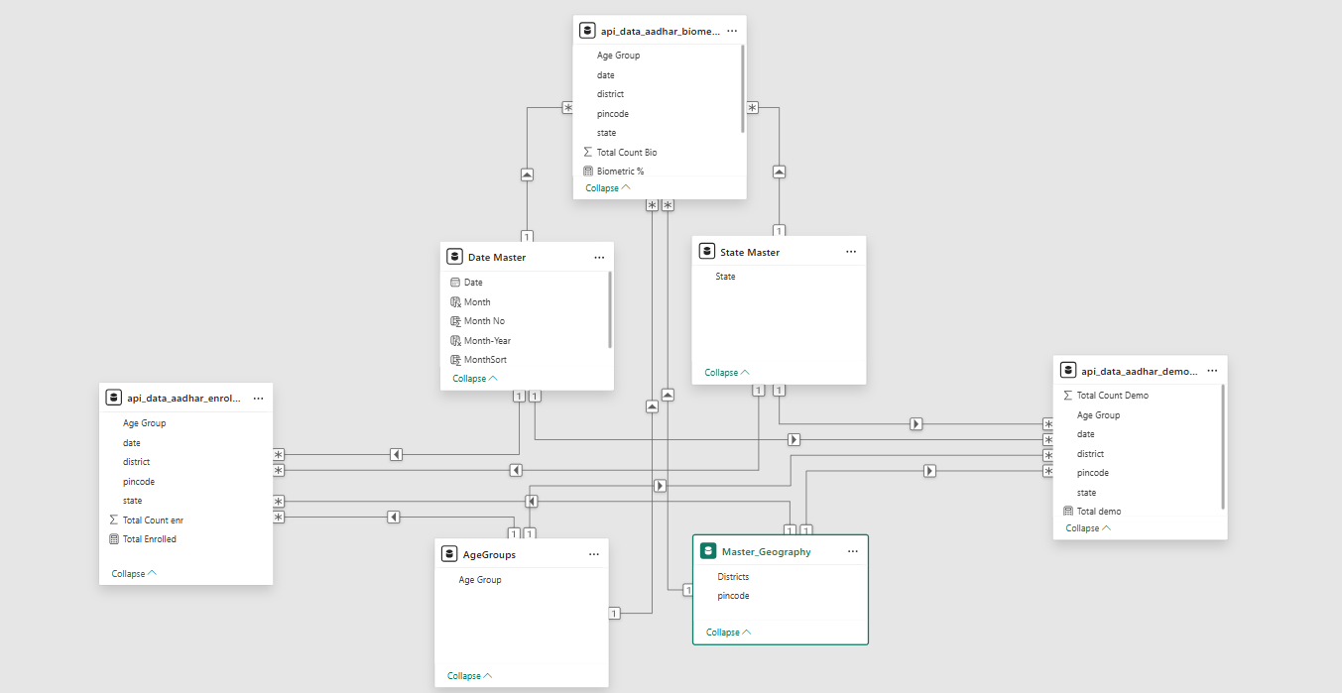
Figure: Power BI Data Model – UIDAI Enrollment, Demographic and Biometric Datasets

Dashboard & Visual Analysis



These Cards are showing-
- Total Aadhaar enrollments, demographic updates, biometric captures, and overall biometric coverage percentage.
- Key insight: Biometric transactions are significantly higher than new enrollments, indicating a large volume of biometric updates for existing Aadhaar holders.
- Biometric and demographic volumes far exceed new enrollments, indicating a mature Aadhaar ecosystem focused on updates rather than expansion.
- Why it matters: UIDAI operations involve not only new enrollments but continuous biometric and demographic maintenance to ensure Aadhaar data accuracy.
- Suggested action: Shift resources from enrollment drives to update optimization and system efficiency.

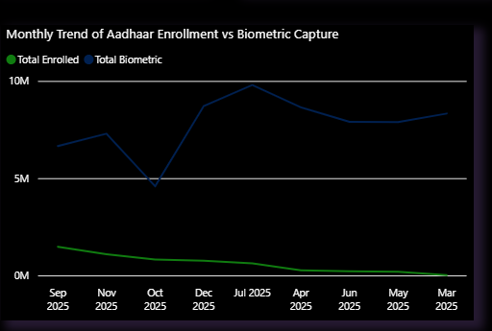

This bivariate analysis is showing –
Month-wise trend of total Aadhaar enrollments and biometric transactions across 2025.
- Biometric activity remains consistently high across all months, significantly exceeding new enrollments, indicating continuous biometric updates for existing Aadhaar holders.
- Peak biometric transactions around mid-2025 suggest periods of intensified update or correction activity rather than enrollment drives.
- Enrollment shows a declining trend over time, indicating saturation of new Aadhaar enrollments in later months.
- The widening gap between biometric and enrollment lines highlights a shift in UIDAI operations from expansion to data maintenance and quality assurance.
- Suggested Action : UIDAI can forecast operational demand and plan staffing proactively.

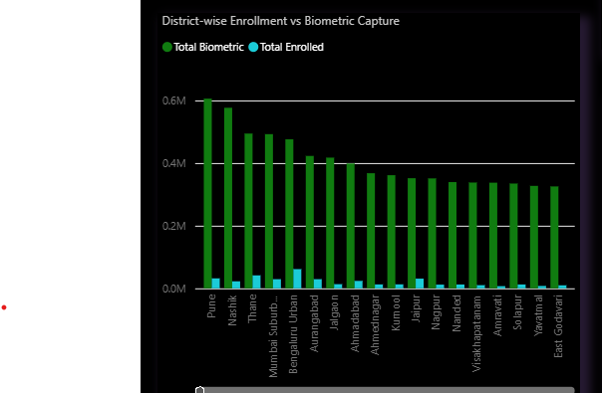
This analysis is showing-
- Districts can be categorized based on the biometric-to-enrollment ratio, revealing distinct operational patterns across the country.
- High biometric and low enrollment districts indicate Aadhaar data maintenance zones where updates, corrections, and re-captures dominate.
- Low biometric and low enrollment districts may represent either saturated coverage or limited operational access.
- Districts where enrollment and biometric volumes are balanced indicate efficient onboarding and completion processes.
- Urban and high-mobility districts show large biometric volumes despite moderate enrollment counts.
- Suggested Action : Identify operational hotspots requiring capacity strengthening.

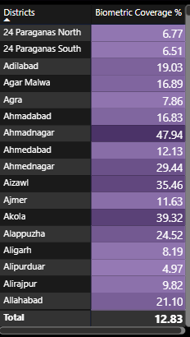
This matrix(heatmap) of District vs Biometric Coverage -
- Biometric coverage varies significantly across districts, indicating uneven completion of Aadhaar biometric processes at the district level.
- Low biometric coverage districts represent priority intervention zones, where enrolled or updated records are not translating into completed biometric capture.
- Moderate to high coverage districts reflect operational efficiency, where enrollment and biometric processes are better aligned.
- The overall biometric coverage of 12.83% represents a weighted national-level completion rate, recalculated using aggregated biometric and eligible population counts rather than a simple district average. This ensures that high-volume districts appropriately influence the overall metric.
- Suggested Action : Prioritize low-coverage districts for targeted biometric campaigns

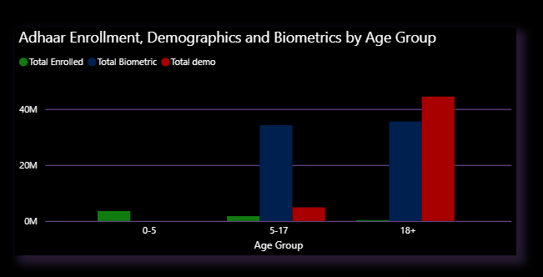
This clustered column chart is showing how different updates vary over age groups-
- Enrollment activity is too minimal in the 5–17 and 18+ age groups, indicating saturation in new Aadhaar creation for these populations.
- Demographic updates are highest for the 18+ groups, reflecting lifecycle-driven changes such as address, name, and personal detail updates.
- Biometric activity is the consistent for these age groups (5-17, 18+), confirming frequent biometric corrections and re-captures over time.
- The 0–5 age group shows enrollment activity but no demographic and biometric records, which aligns with Aadhaar’s lifecycle design where biometrics are captured later.
- Biometric updates are high in both 5–17 and 18+ groups, while demographic updates increase sharply only in the 18+ population, indicating higher lifecycle-driven changes among adults.
- This suggests that adults drive most demographic update demand, whereas adolescents mainly contribute to biometric update volumes.
- Suggested Action : UIDAI can differentiate operational strategies by age group, focusing enrollment efforts on early childhood (0–5) while optimizing demographic and biometric update workflows for older populations where lifecycle changes drive system load.

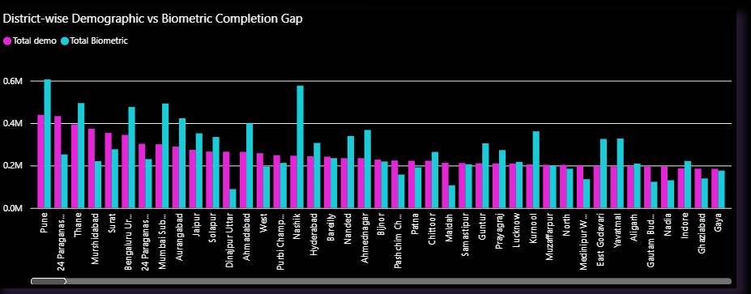
This graph is showing that –
- Biometric activity consistently exceeds demographic updates across most districts, indicating higher frequency of biometric corrections and re-captures compared to demographic changes.
- High-activity districts (e.g., Pune, Nashik, Mumbai Suburban) show a larger biometric–demographic gap, suggesting operational load driven by urban mobility, corrections, and service demand rather than new data capture.
- Several districts display near parity between biometric and demographic volumes, reflecting more balanced Aadhaar lifecycle management and comparatively stable resident data.
- The presence of both positive and minimal gaps highlights regional variability in Aadhaar update behavior, emphasizing the need for district-specific operational planning rather than uniform policy enforcement.
- Suggested Action : UIDAI should strengthen biometric infrastructure and staffing in districts with high biometric dominance, while using balanced districts as benchmarks for efficient service delivery.

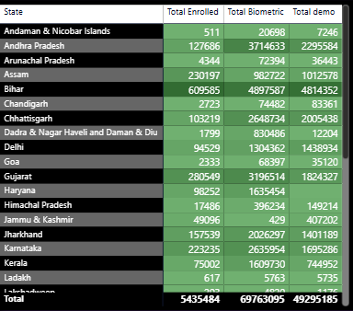

- The state-wise matrix highlights significant variation in enrollment, demographic updates, and biometric capture volumes, enabling UIDAI to identify states with high operational load versus those requiring targeted outreach or capacity enhancement.
- Uttar Pradesh consistently records the highest volumes across enrollment, demographic updates, and biometric capture, indicating both its population scale and sustained Aadhaar service demand, thereby requiring continuous capacity planning and resource prioritization.
Final Summary
This analysis provides a comprehensive view of Aadhaar enrollment, demographic updates, and biometric capture patterns across districts, age groups, and time. Each visual was designed to answer a specific operational question relevant to UIDAI decision-making. The dashboard reveals that Aadhaar operations in 2025 are largely update-driven rather than enrollment-driven, with biometric transactions significantly exceeding new enrollments and demographic updates. District-level analysis highlights substantial regional variation in biometric coverage and completion gaps, while age-group trends show consistent operational behavior across populations. The use of standardized geographic correction via a master pincode-to-district mapping ensures reliable, decision-ready insights.

Key Recommendations
- Transition from Enrollment-Centric to Lifecycle-Centric Aadhaar Management
The analysis clearly indicates that Aadhaar operations are now dominated by biometric and demographic updates rather than new enrollments. UIDAI should reorient its operational strategy to prioritize lifecycle updates, ensuring faster, more reliable update services for existing Aadhaar holders.
- Adopt District-Level Differential Resource Allocation
Significant variation in biometric–demographic gaps across districts highlights the need for localized planning. UIDAI should move away from uniform deployment and instead allocate infrastructure, manpower, and mobile units based on district-specific operational load.
- Use Biometric Coverage as a Core Performance Indicator
Biometric coverage percentage should be institutionalized as a key monitoring metric to identify underperforming districts early and trigger targeted interventions before service backlogs emerge.
- Implement Age-Specific Service Design
Different age groups interact with Aadhaar in fundamentally different ways. UIDAI should focus enrollment accessibility for early childhood while optimizing biometric and demographic update workflows for adolescents and adults where update demand is highest.
- Strengthen Data Standardization and Geographic Validation
The need for a master geographic correction layer underscores the importance of standardized location tagging. UIDAI should enforce pincode-based district validation to improve reporting accuracy and enable reliable decision-making.
- Enable Predictive Operational Planning Using Trend Analysis
Consistent biometric activity trends can be leveraged as early indicators of future workload. UIDAI can use historical patterns to anticipate demand spikes and proactively scale capacity rather than reacting post-facto.
Single Line Conclusion
This analysis demonstrates how Aadhaar operational data can be transformed from descriptive reporting into a decision-support framework for proactive governance.

------------------------------------------------------------------------------------------------------------------------------------------------------------------------------------
Thank you for the opportunity to present this analysis. The insights and recommendations aim to support UIDAI in strengthening operational efficiency, coverage, and governance through data-driven decision-making.
Email - anushkaofficial183@gmail.com

Dashboard Appendix
The following pages present the interactive dashboard developed to visually support the analysis, insights, and recommendations discussed in this document.
The dashboard pages are presented in landscape orientation for optimal visual clarity.

